Soil Review

1. Why is soil a valuable natural resource? _________________________________________________________

C:\Users\snidab\AppData\Local\Microsoft\Windows\Temporary Internet Files\Content.IE5\PL8183MY\MC900036777[1].wmf

1. Write two examples of ways farmers help to conserve soil.

____________________________________

____________________________________

1. How is soil formed? _________________________________________
2. Explain 3 different ways this can occur. ________________________,

________________________________________________________,

_________________________________________________________.

1. Soil is made up of many components. List 4 components of soil.
   1. ________________________________
   2. ________________________________
   3. ________________________________
   4. ________________________________

[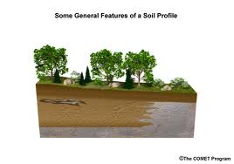](http://www.google.com/url?sa=i&rct=j&q=soil+profile&source=images&cd=&cad=rja&uact=8&ved=0CAcQjRw&url=http://www.meted.ucar.edu/hydro/basic_int/runoff/navmenu.php?tab=1&page=4.3.0&ei=GpdHVPjqEYiZyATQiYHwDQ&bvm=bv.77880786,d.aWw&psig=AFQjCNEreQCsf8JrCr0vhxA7xfNTuraiGg&ust=1414064226377577)

1. Label the soil horizons.

Label with A, B, C, O AND humus, topsoil, subsoil & bedrock

7. What is permeability? _____________________________________________________________

8. Which soil type would be the least permeable? _____________________

Would you want your yard mainly made of this type of soil? Explain your reasoning. ____________________________________________________________________________________________________________________

_________________________